Experiment No: 08 Machine Learning

Aim:
Plot ROC curves for a binary classifier, comparing AUC scores for different algorithms.

Objective:
• To understand the concept of ROC curves and AUC scores for model evaluation.
• To compare classification performance of multiple algorithms using ROC-AUC.
• To visualize how well models distinguish between positive and negative classes.
• To gain insights into classifier trade-offs between sensitivity and specificity.

Prerequisites:
• Software: Python 3.x with scikit-learn, matplotlib, pandas.
• Hardware: A computer with at least 4 GB RAM.
• Skills: Knowledge of binary classification and evaluation metrics.

Theory:
The Receiver Operating Characteristic (ROC) curve is a graphical representation of a binary classifier’s performance. It plots the True Positive Rate (TPR) against the False Positive Rate (FPR) at various threshold settings.
The Area Under the Curve (AUC) quantifies the overall ability of the model to discriminate between the positive and negative classes. A higher AUC value indicates better model performance. An AUC of 0.5 represents random guessing, while 1.0 represents perfect classification.
By comparing ROC curves of different models, we can visually determine which algorithm performs best. In this experiment, Logistic Regression, Random Forest, and Support Vector Machine (SVM) models are compared.

Apparatus/Software Requirements:
• Python IDE (Jupyter Notebook, VS Code, etc.).
• Required Python libraries: pandas, scikit-learn, matplotlib.
• Dataset: Pima Diabetes dataset (CSV format).

Procedure:
Step 1: Load the Pima Diabetes dataset.
Step 2: Split the data into features (X) and target (y).
Step 3: Divide the dataset into training and testing sets.
Step 4: Standardize features using StandardScaler.
Step 5: Define multiple classifiers – Logistic Regression, Random Forest, and SVM.
Step 6: Train each model on the training set and predict probabilities on the test set.
Step 7: Compute ROC curve and AUC score for each model.
Step 8: Plot all ROC curves on a single graph for comparison.
Step 9: Interpret the AUC scores to determine the best-performing algorithm.

Program Code:
import pandas as pd
import matplotlib.pyplot as plt
from sklearn.model_selection import train_test_split
from sklearn.preprocessing import StandardScaler
from sklearn.linear_model import LogisticRegression
from sklearn.ensemble import RandomForestClassifier
from sklearn.svm import SVC
from sklearn.metrics import roc_curve, auc, roc_auc_score
# Load dataset
df = pd.read_csv("Pima_diabetes.csv") # your dataset
# Split features and target
X = df.drop('Outcome', axis=1)
y = df['Outcome']
# Train-test split
X_train, X_test, y_train, y_test = train_test_split(X, y, test_size=0.2, random_state=42)
# Scale features
scaler = StandardScaler()
X_train = scaler.fit_transform(X_train)
X_test = scaler.transform(X_test)
# Define models
models = {
"Logistic Regression": LogisticRegression(),
"Random Forest": RandomForestClassifier(),
"SVM": SVC(probability=True)
}
# Plot ROC curves
plt.figure(figsize=(7,6))
for name, model in models.items():
model.fit(X_train, y_train)
y_probs = model.predict_proba(X_test)[:, 1]
fpr, tpr, _ = roc_curve(y_test, y_probs)
roc_auc = auc(fpr, tpr)
plt.plot(fpr, tpr, label=f'{name} (AUC = {roc_auc:.2f})')
print(f"{name} (AUC = {roc_auc:.2f})")
# Random chance line
plt.plot([0, 1], [0, 1], linestyle='--', color='gray', label='Random Chance')
# Chart details
plt.title('ROC Curves for Different Algorithms')
plt.xlabel('False Positive Rate')
plt.ylabel('True Positive Rate')
plt.legend(loc='lower right')
plt.grid(alpha=0.3)
plt.show()

Expected Output:
- Plot of ROC curves showing classifier performance.
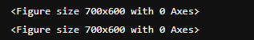
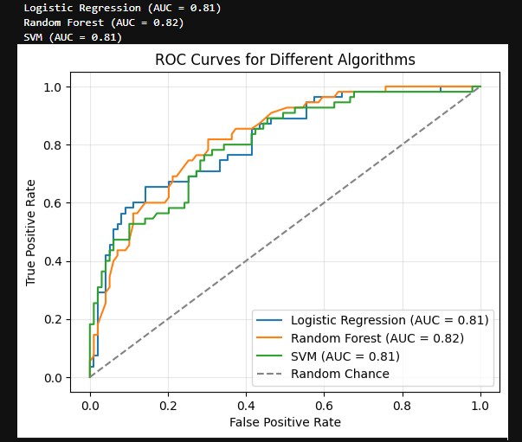
- Display AUC scores for Logistic Regression, Random Forest, and SVM models & Identification of the best-performing model based on highest AUC.

Observations:
The ROC curves provide a clear comparison of classifier performance. Models with curves closer to the top-left corner indicate higher true positive rates with lower false positive rates. The AUC values help quantify this difference objectively.

Conclusion:
This experiment compared multiple classification algorithms using ROC and AUC metrics. It demonstrated that ROC-AUC analysis is an effective method to evaluate model performance and select the most reliable classifier for binary prediction tasks.

Viva Questions:
• What does the ROC curve represent?
• How is the AUC score interpreted?
• Why do we use probabilities for plotting ROC curves?
• What does an AUC value of 0.5 signify?
• Which algorithm performed best based on AUC in this experiment?

